Git Configuration

Basic Git Commands

1. **git init** : This command is used to create a local repository.



1. **git add .** : This command is used to add one or more files to staging (Index) area.



1. **git commit –m “commit message”** :This command changes the head. It records or snapshots the file permanently in the version history with a message.
2. **git commit –a** : This command commits any files added in the repository with git add and also commits any files you've changed since then.

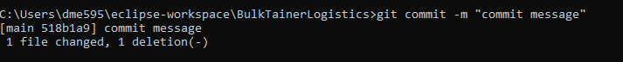

1. **git push :** It is used to upload local repository content to a remote repository.

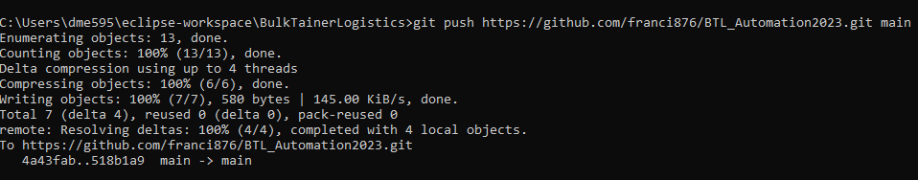

1. **git clone URL**  : This command is used to make a copy of a repository from an existing URL. If I want a local copy of my repository from GitHub, this command allows creating a local copy of that repository on your local directory from the repository URL.

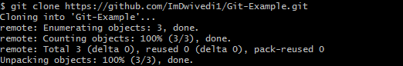

1. **git status** : It allows you to see which changes have been staged, which haven't.

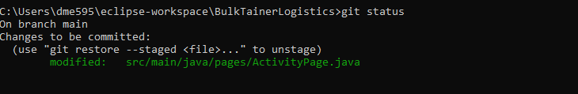

1. **git pull URL** : Pull command is used to receive data from GitHub. It fetches and merges changes on the remote server to your working directory.

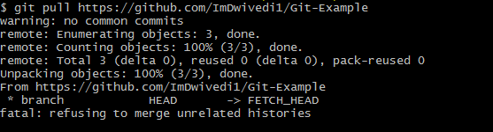

1. **git branch :** This command lists all the branches available in the repository.



1. **git log** : This command is used to check the commit history.

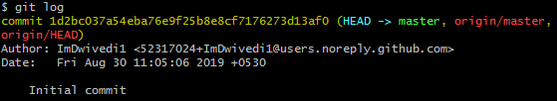

Push Code to Git Hub

Step 1: Login to git hub then click on new button

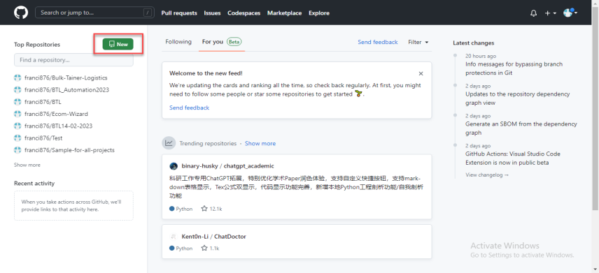

Step 2: Enter a repository name

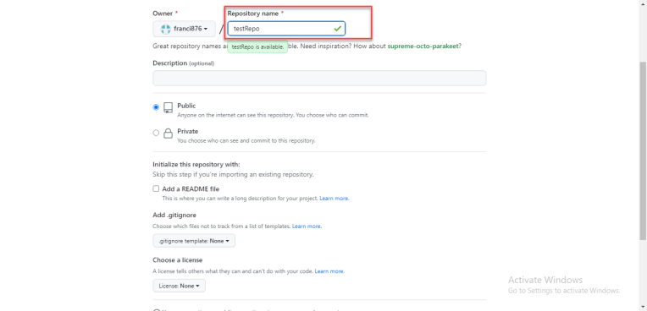

Step 3: Click on the public radio button to create repository as public then click on create repository button.

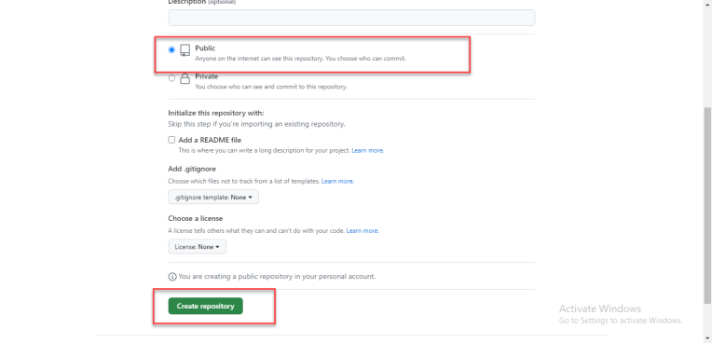

Step 4: Then go to the project folder you want to upload to git then enter cmd at top where the file location shows then click enter

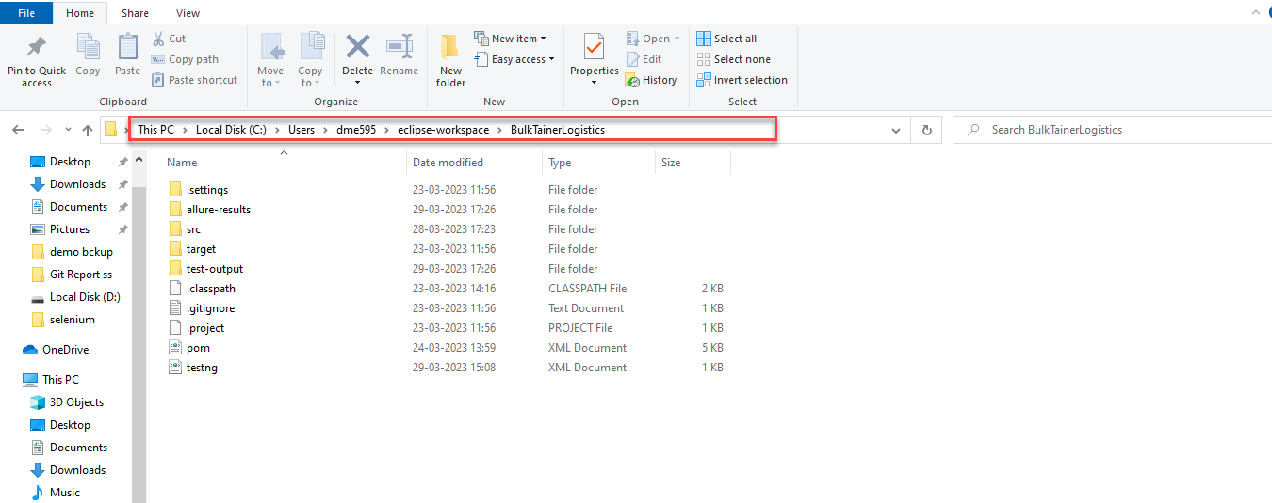

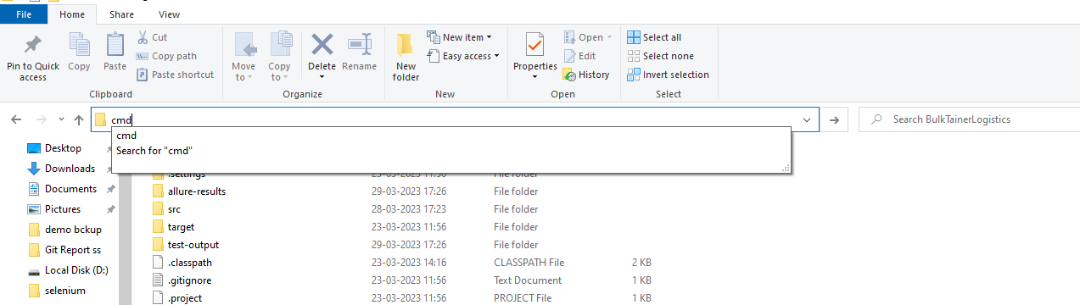

Step 5: Now command prompt will opens up and then enter following commands

1. git init
2. git add .
3. git commit –m “first commit”
4. git branch –m main
5. git push URL

eg: git push https://github.com/franci876/testRepo.git

Now code is pushed to Git repository created.

Git Clone

To get a code from a repository to our device we can use git clone command